Press Release for LINE \

Exhibition Details:
- Group Exhibition featuring the work of Carlos Beltran Arechiga, Lynne Berman, Margaret Griffith, Iva Gueorguieva, Cameron Harvey, Francesca Lelanne, Suwichada Busamrong- Press, and Rebecca Ripple
- On View: 10/22- 12/16;
- Opening Reception: 10/22 at 5-8pm
- Location: Vama Gallery, DH Hall, Los Angeles City College, 855 N Vermont Ave, Los Angeles, CA 90029

Vama Gallery is proud to present LINE \ a group exhibition featuring the works of eight Los Angeles-based artists. Opening on the eve of the midterm elections, this exhibition brings together Carlos Beltran Arechiga, Lynne Berman, Margaret Griffith, Iva Gueorguieva, Cameron Harvey, Francesca Lelanne, Suwichada Busamrong Press, and Rebecca Ripple.

Despite the clarity of demarcation, a line embodies an inherent paradox—it makes amorphous space and immaterial worlds visible by contrast. The artists in this show explore how an understanding of intangible realities exists outside—and because of—the finite clarity of a line. At a moment when public discourse is saturated with high-stakes ultimatums like "a red line in the sand," "redrawing lines," and "all is on the line," LINE \ serves as a visceral antidote to the entrapment and dehumanization felt within systems of technology, AI, and political oppression. Rejecting digital media, these artists lean heavily into the body-oriented process and labor of "making." The physicality of their processes and materials feel transgressive in the face of this moment, and reveal deeper truths that remind us how to remain present, and connected to a lived experience at a time and place that needs us to feel and listen carefully

Carlos Beltran Arechiga Penumbra XI reflects on imaginary lines of conflict, visibility, and belonging. It juxtaposes amorphous, imaginary beings against hazy architectural lines, and sharp, incongruous lines to emphasize the transitoriness of man-made structures, forcing bodies and lives into experiences that exist at the edges

Lynne Berman Green Mound, Unburied, the culmination of an obsessive three-year isolation process during the COVID-19 pandemic. By staining, cutting, and gluing recycled paper scraps into expanding concentric circles of greens and turquoises, Berman delivers an epic collage that meditates on sustainability, existence, and a universal force.

Margaret Griffith’s textile work was created as a direct response to trauma after losing her home and studio in the Altadena fires. Her piece, Echo, utilizes unprimed blackened canvas hand-punched with circular patterns to reference perforated architectural steel, creating a haunting exploration of memory, loss, and impermanence.

Iva Gueorguieva’s Tree 2, a massive, unstretched canvas functions as a physical field recording. Composed of folded and glued on colored gauze, blotches, and smears, the piece archives the direct imprints of Gueorguieva’s limbs and body, mapping the intersections of intentional force and accidental touch, listening and feeling.

Francesca Lelanne engraves steel plates to transform lines into physical records of endurance, memory, and history. Her work explores the body as a form of architecture that shelters emotional weight, bridging the spaces we physically inhabit with the inner worlds we carry. Ultimately, Lelanne questions how the structures we occupy—and become for one another—shape our capacity to heal.

Cameron Harvey : The central midline and bilateral symmetry of her unstretched, shaped, and richly colored canvasses are inspired by found leaves. The same structure of a midline with two sides creates room for endless formal possibilities and a deeper understanding of the interconnectedness between diverse organisms, like leaf and human

Suwichada Busamrong- Press: a colossal, hand-sewn work of fermented linen stained with turmeric, clay, and marigolds utilizes natural pigments to tap into ancestral knowledge and earth-bound healing. Busamrong-Press uses deliberate cuts, rips, and stitches to map the fragile relationship between vulnerability, loss, and healing.

Rebecca Ripple investigates the unseen systems that constrain, disturb bodies and boundaries. Her sculpture explores entrapment through a long line of a bent steel rod that suggests a fluid, scripted gesture but is rigidly trapped within a mattress-pattern matrix. Flattened peaks and intentional glitches highlight the invisible, heavy forces that prevent the form from reaching full extension

For media inquiries, high-resolution images, please contact Alexandra Wiesenfeld alexandraiwiesenfeld@gmail.com
Phone: 2136778504
Email: vamagallery@gmail.com
Website: vamagallery.com

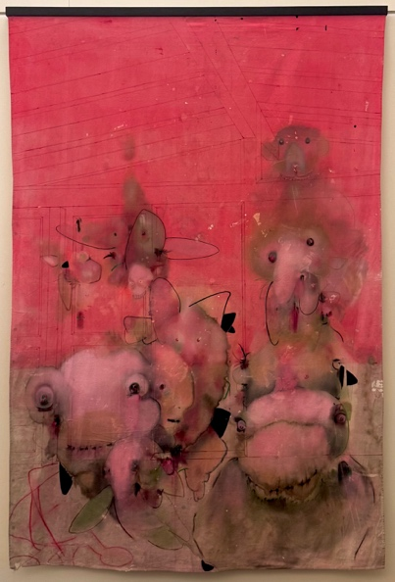
Carlos Beltran Arechiga
Penumbra XI
2026
aged coﬀee, acrylic, oil, on construction tarp
96” x 66 “

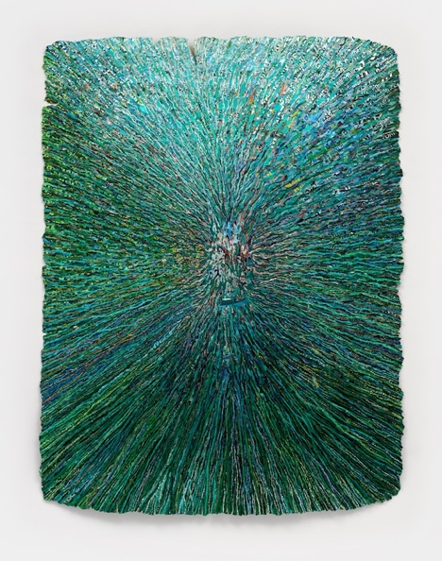
Lynne Berman
Green Mound, Unburied
2023
Collage on paper
58” x 43 “

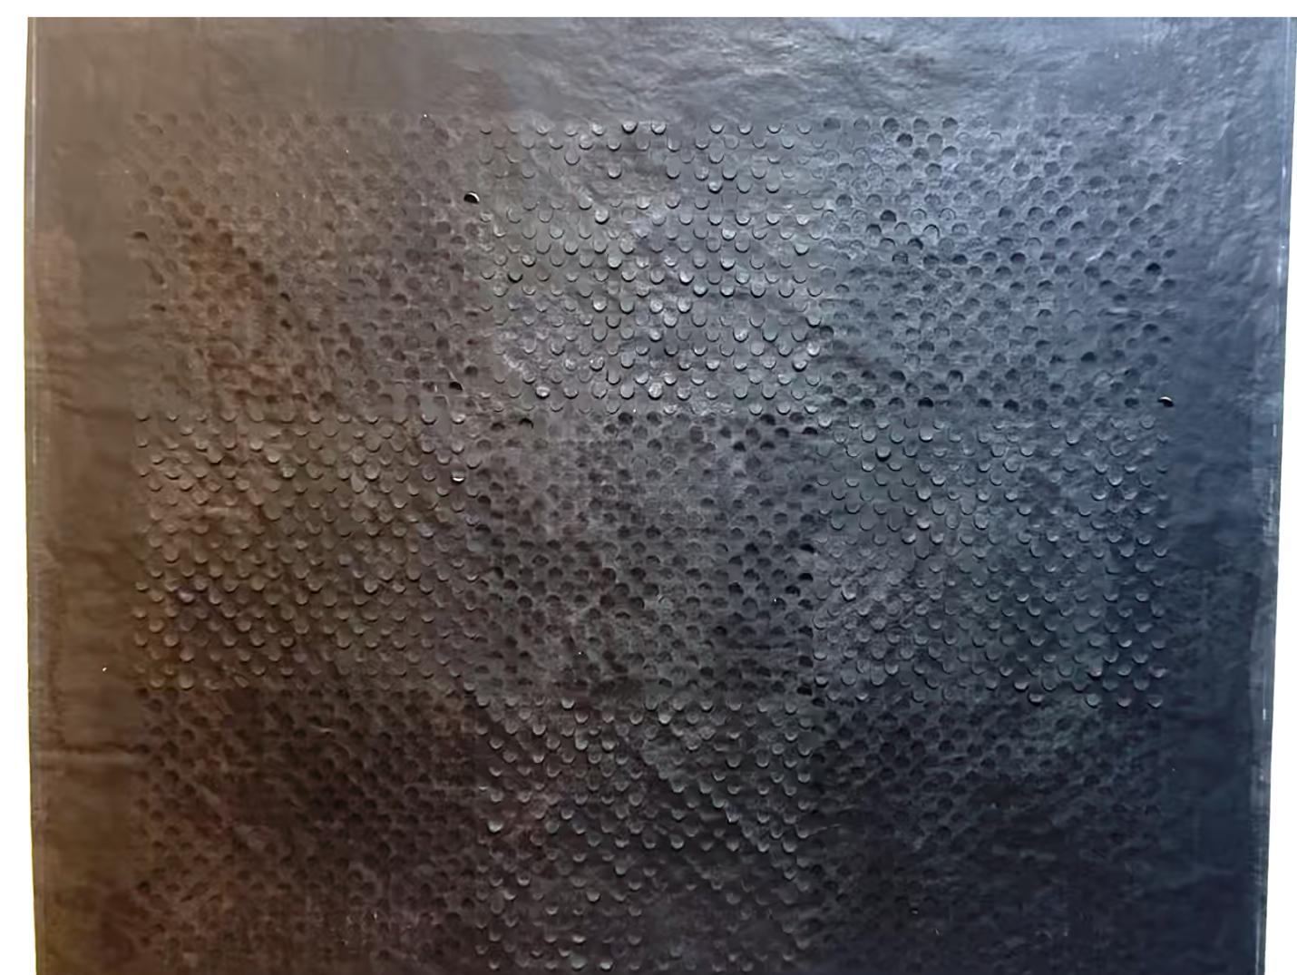
Margaret Griffith
Echo
2026
Ink and glue on canvas
62” x 53”

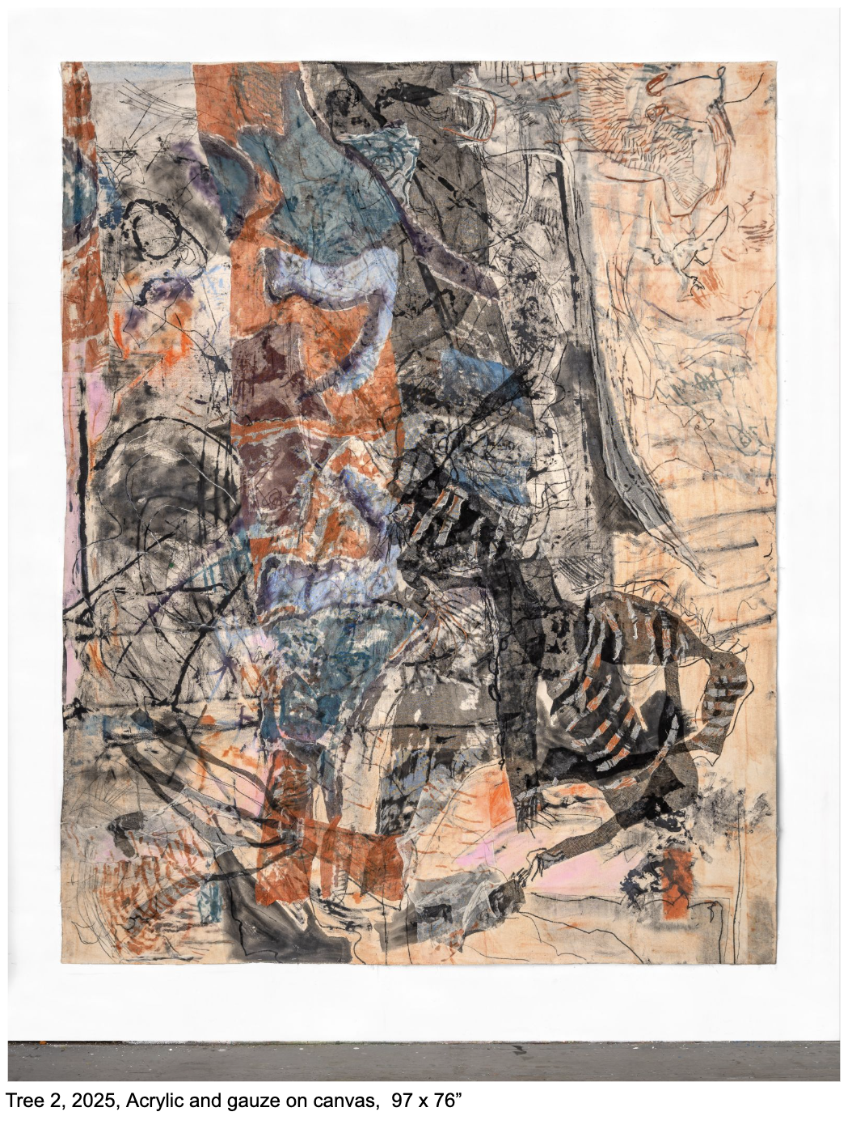
Iva Gueorguieva
Tree 2
2025
Acrylic and Gauze on Canvas
97” x 76 “

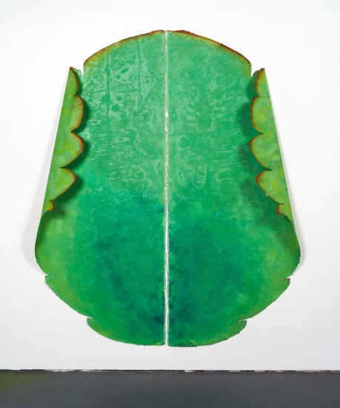
Cameron Harvey
Ancestor 47
2025
Acrylic on Canvas
85” x 64
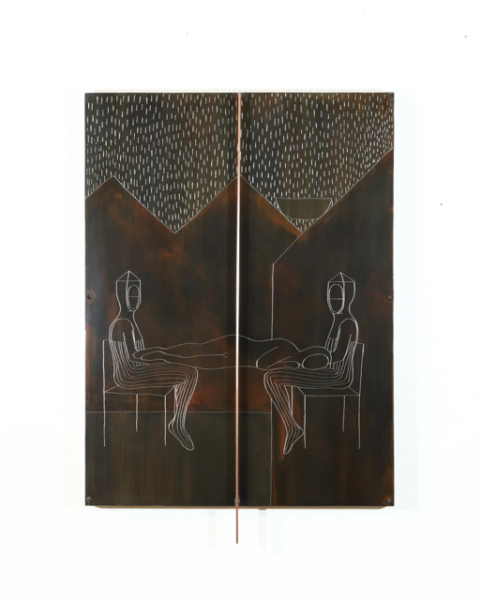

Francesca Lalanne
Repoze 2025
Engraved steel, patina, copper bar
24" x 18" x 2 ³⁄₄"

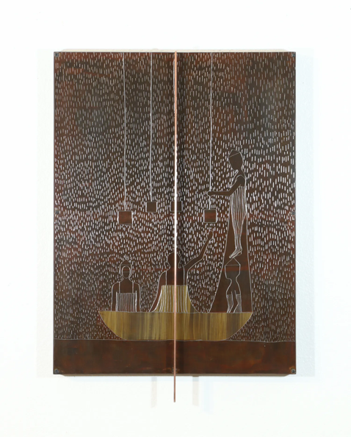
Francesca Lalanne
“Rèv,”
2025
Engraved steel, patina, copper bar
24" x 18" x 2 ³⁄₄"

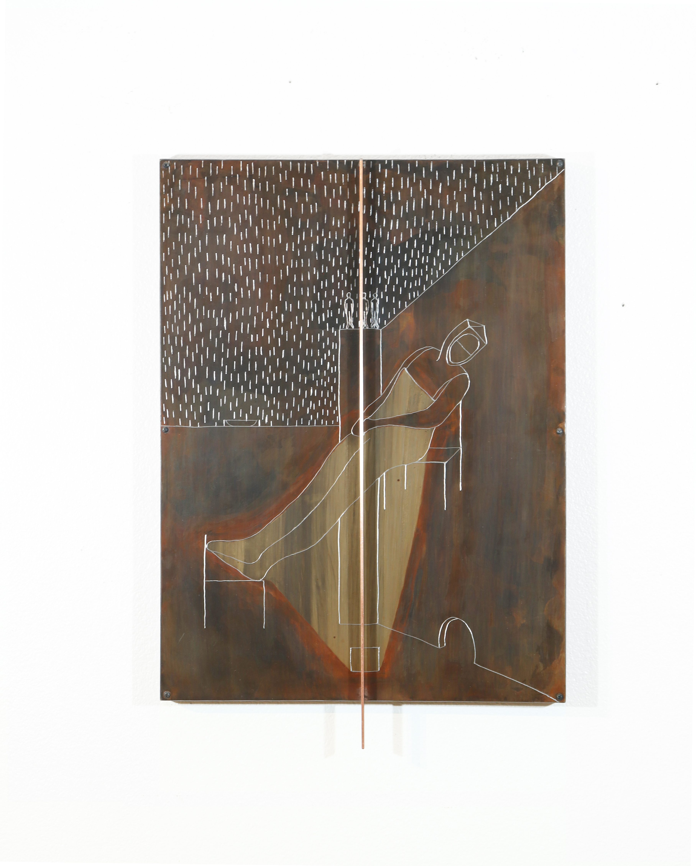

Francesca Lalanne
“Pasyans” (Patience)
2025
Engraved steel, patina, copper bar
24" x 18" x 2 3⁄4"

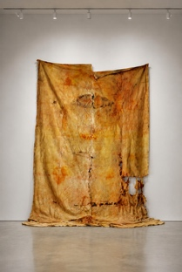

Suwichada Busamrong- Press
When the Light Entered
2026
12” x 60 “

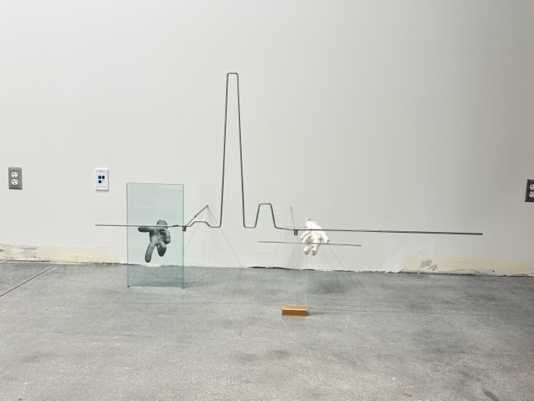
Rebecca Ripple
Compress
2026
Steel, acrylic sheet, plaster, powder coating

